**K8S Authorization**

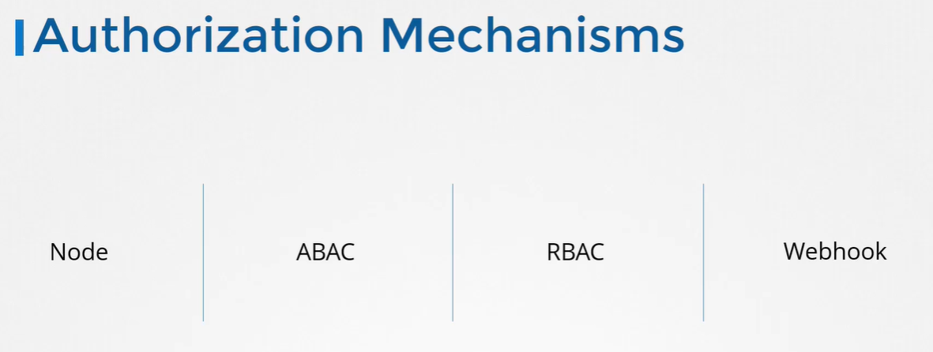

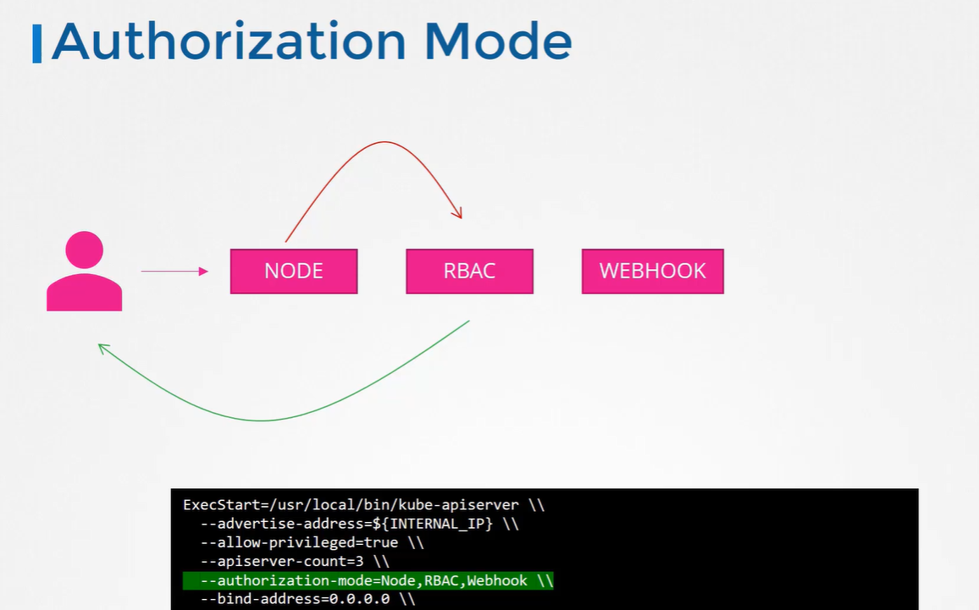

1. Node

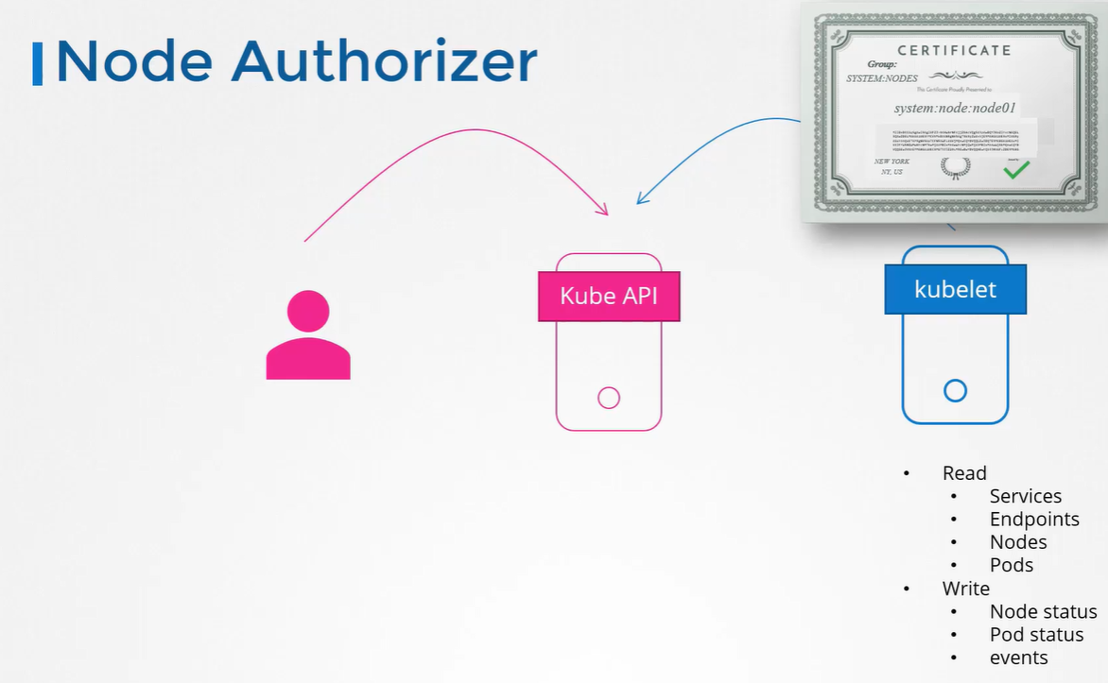

Any request coming from user with system:node and part of SYSTEM:NODES group is authorized by node authorizer and grant privilege

1. ABAC

External access to the API

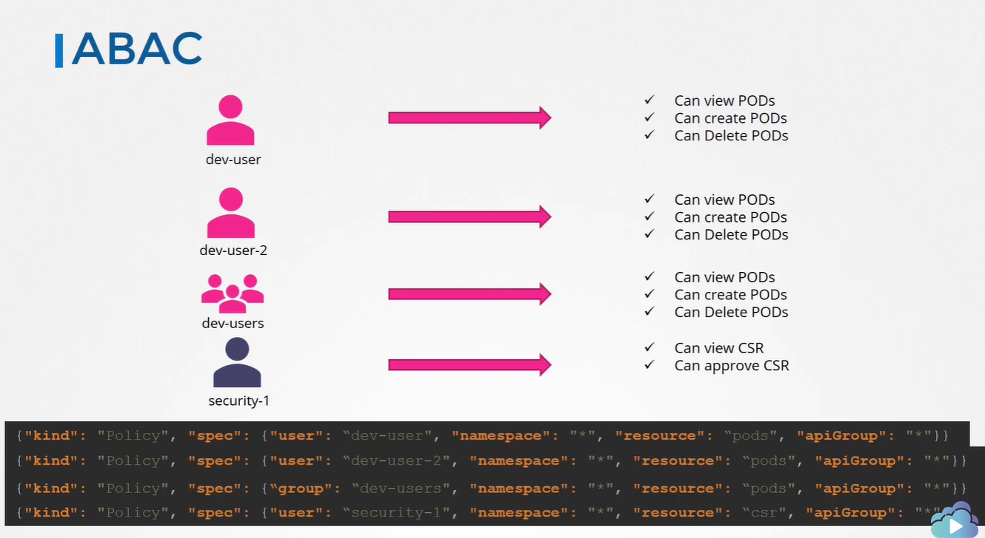

Configuration in json format, passing these file into kube-apiserver

Need to restart kube-apiserver every time

1. RBAC

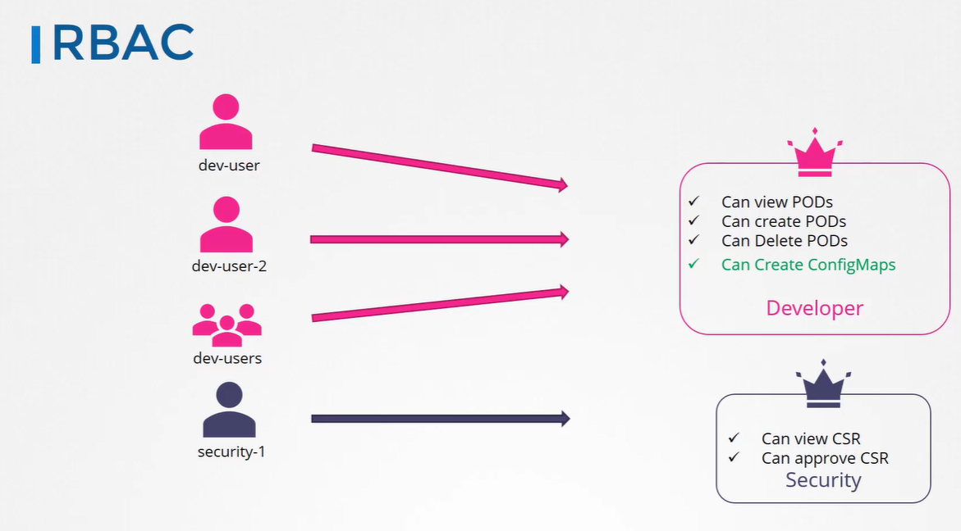

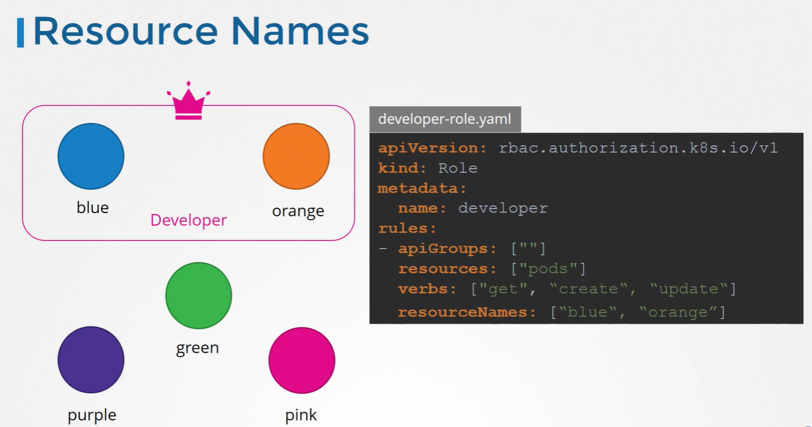

1. Webhook

Outsource the authorization work to 3rd party software

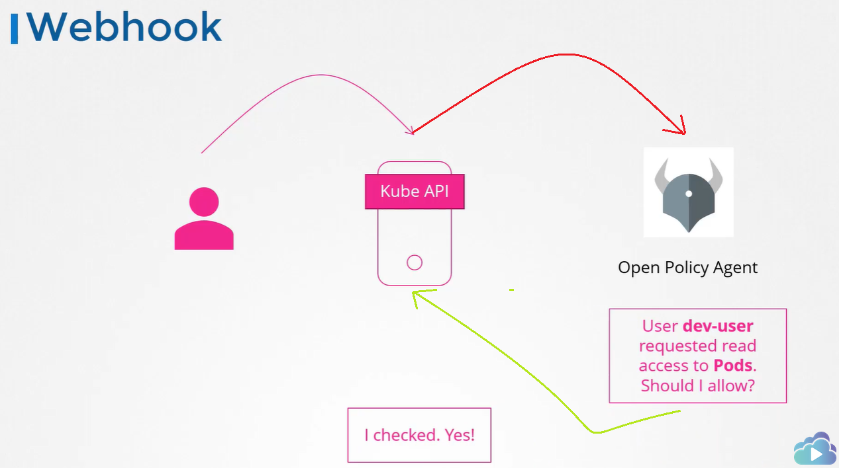

1. AlwaysAllow

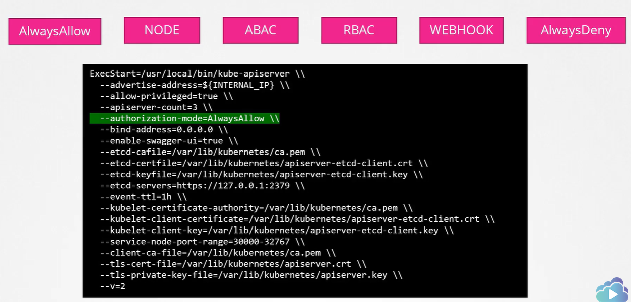

1. AlwaysDeny